**WITH NOISE AND WITH FILTER**

**Image set:**

|  |
| --- |
| **Image 1:-0.1 % Noise** |

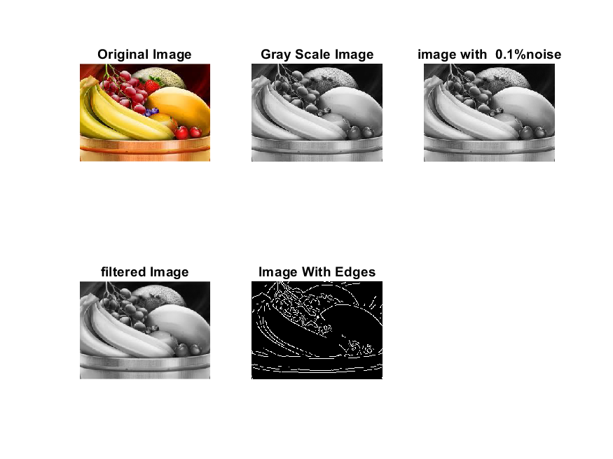

**Image 2:-10 % Noise**

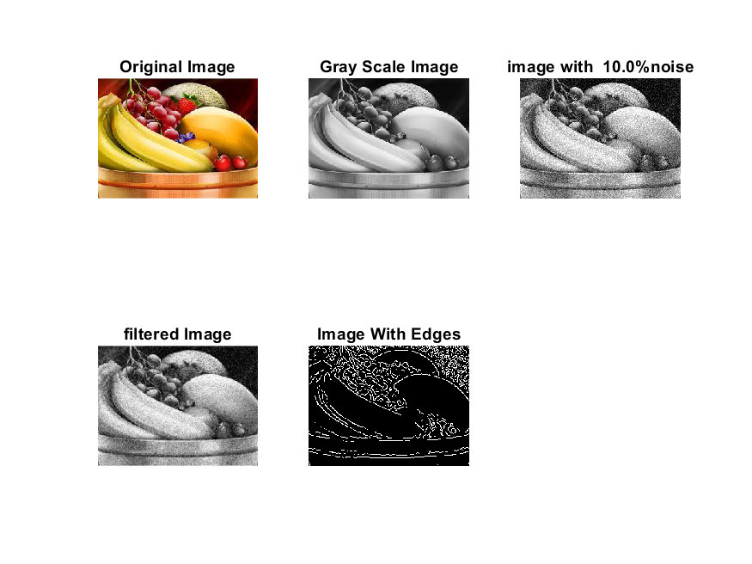

**Image 3:-20 % Noise**

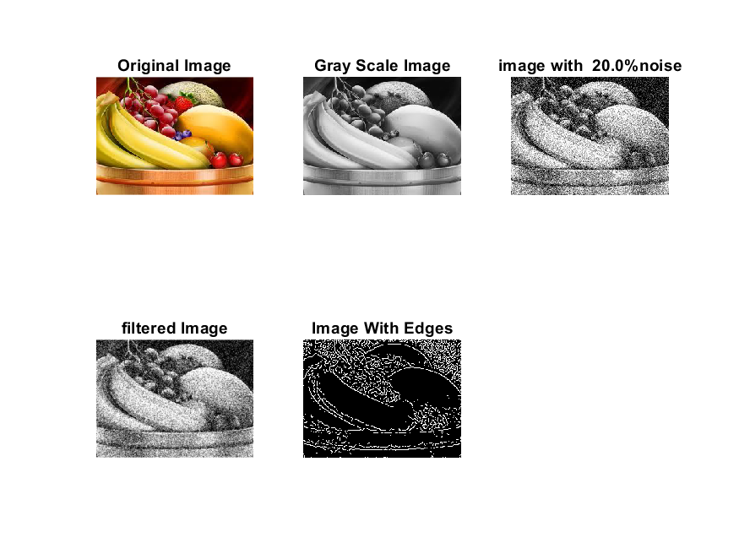

**Image 4:-30 % Noise**

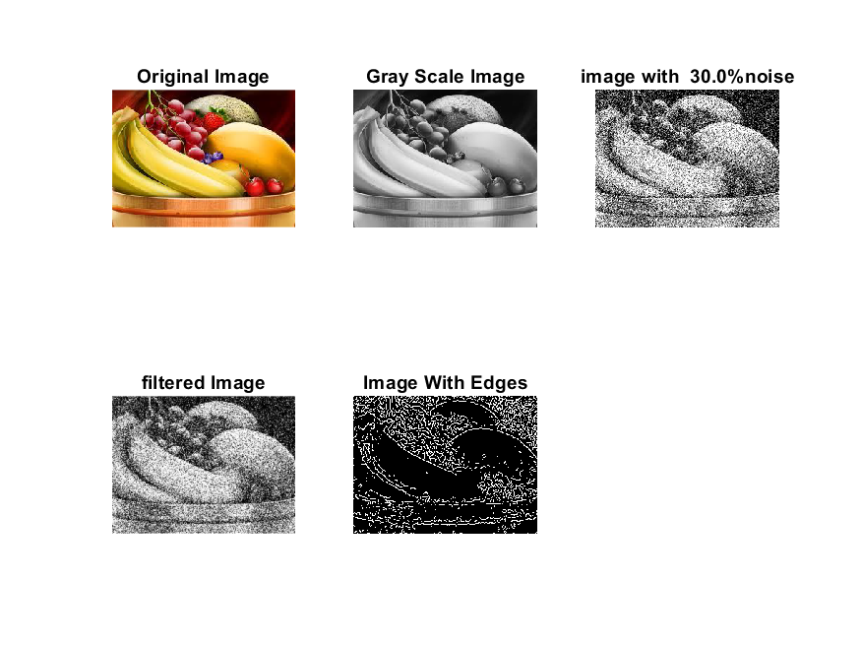

|  |
| --- |
| **Image 5:-40 % Noise** |

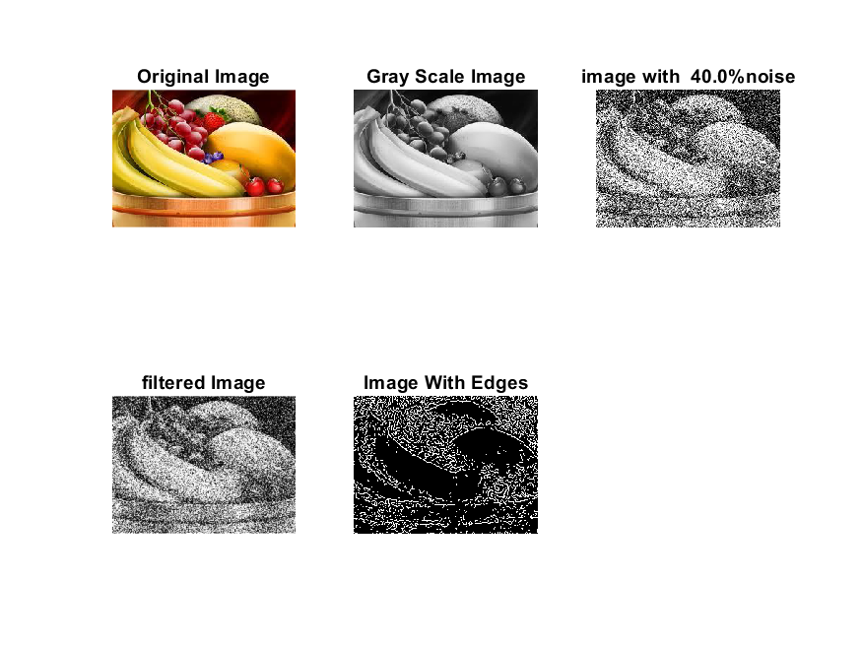

**Image 6:-50 % Noise**

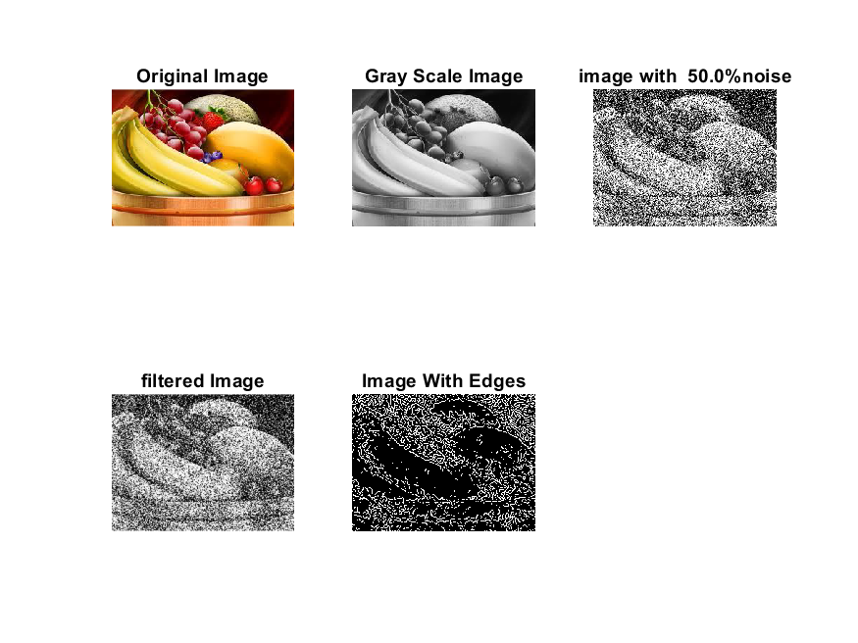

**Image 7:-60 % Noise**

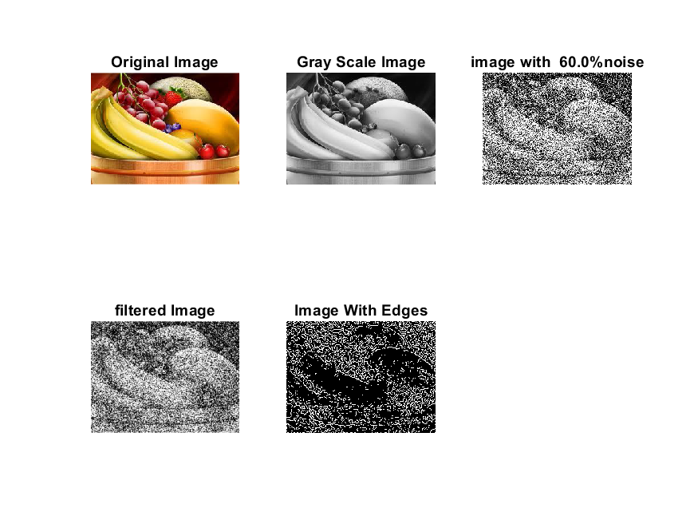

**Image 8:-70 % Noise**

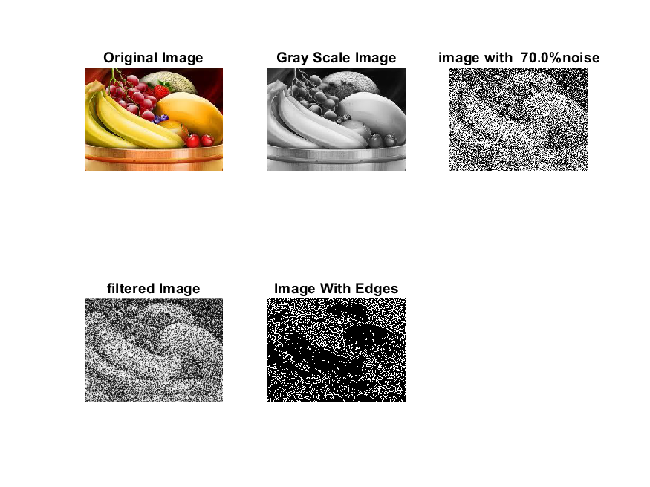

**Image 9:-80 % Noise**

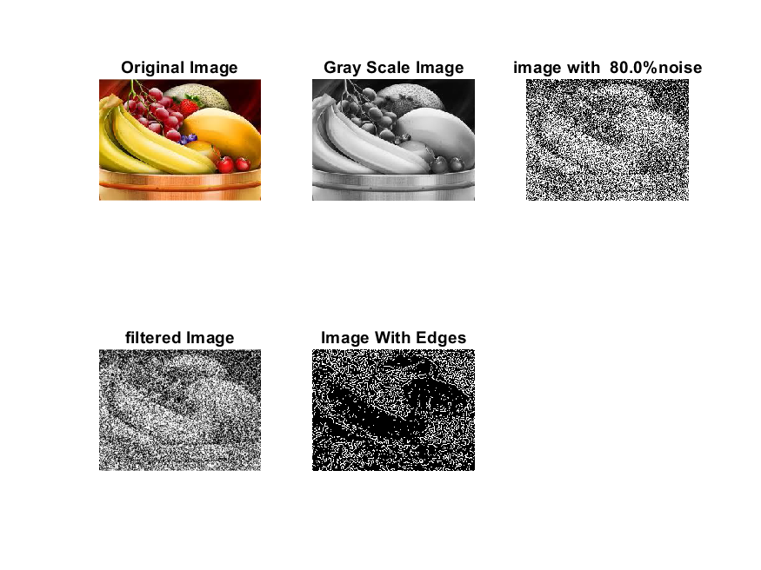

**DATA FILES**

**Image 1:-Noise0.1**

Original image ideal values:

IM1 image entropy:4.016404e-01

IM1 image mean:0.079847

Ground truth image entropy:0.815119

Ground truth image mean:0.252438

entropy between imt and im1 :0.772222

MSE between imt and im1 :0.280818

Average Difference between imt and im1 :0.172591

Maximum Difference between imt and im1 :1.000000

True Positive values:1293.000000

False Positive values: 2719.000000

True Negative values:34843.000000

False Negative values:11391.000000

Accuracy value: 0.719182

F Measure values:0.154887

Peak Signal-to Noise Ration value: 5.515745

Signal-to Noise Ration value: -4.998953

percentage of pixels that were correctly detected (Pco): 0.101939

The percentage of pixels that were not detected (Pnd):0.898061

the percentage of false alarm: (Pfa):0.214365

Euclidean Distance Value :9.283886

**Image 2:-Noise10**

Original image ideal values:

IM1 image entropy:5.063025e-01

IM1 image mean:0.112128

Ground truth image entropy:0.815119

Ground truth image mean:0.252438

entropy between imt and im1 :0.765326

MSE between imt and im1 :0.305378

Average Difference between imt and im1 :0.140310

Maximum Difference between imt and im1 :1.000000

True Positive values:1487.000000

False Positive values: 4147.000000

True Negative values:33415.000000

False Negative values:11197.000000

Accuracy value: 0.694622

F Measure values:0.162354

Peak Signal-to Noise Ration value: 5.151629

Signal-to Noise Ration value: -3.524394

percentage of pixels that were correctly detected (Pco): 0.117234

The percentage of pixels that were not detected (Pnd):0.882766

the percentage of false alarm: (Pfa):0.326947

Euclidean Distance Value :10.807922

**Image 3:-Noise20**

Original image ideal values:

IM1 image entropy:5.787692e-01

IM1 image mean:0.137921

Ground truth image entropy:0.815119

Ground truth image mean:0.252438

entropy between imt and im1 :0.752124

MSE between imt and im1 :0.316762

Average Difference between imt and im1 :0.114517

Maximum Difference between imt and im1 :1.000000

True Positive values:1849.000000

False Positive values: 5081.000000

True Negative values:32481.000000

False Negative values:10835.000000

Accuracy value: 0.683238

F Measure values:0.188539

Peak Signal-to Noise Ration value: 4.992676

Signal-to Noise Ration value: -2.625230

percentage of pixels that were correctly detected (Pco): 0.145774

The percentage of pixels that were not detected (Pnd):0.854226

the percentage of false alarm: (Pfa):0.400583

Euclidean Distance Value :13.644079

**Image 4:-Noise30**

Original image ideal values:

IM1 image entropy:6.364307e-01

IM1 image mean:0.160888

Ground truth image entropy:0.815119

Ground truth image mean:0.252438

entropy between imt and im1 :0.737252

MSE between imt and im1 :0.324046

Average Difference between imt and im1 :0.091550

Maximum Difference between imt and im1 :1.000000

True Positive values:2243.000000

False Positive values: 5841.000000

True Negative values:31721.000000

False Negative values:10441.000000

Accuracy value: 0.675954

F Measure values:0.216005

Peak Signal-to Noise Ration value: 4.893937

Signal-to Noise Ration value: -1.956299

percentage of pixels that were correctly detected (Pco): 0.176837

The percentage of pixels that were not detected (Pnd):0.823163

the percentage of false alarm: (Pfa):0.460501

Euclidean Distance Value :16.737747

**Image 5:-Noise40**

Original image ideal values:

IM1 image entropy:6.822370e-01

IM1 image mean:0.180990

Ground truth image entropy:0.815119

Ground truth image mean:0.252438

entropy between imt and im1 :0.727812

MSE between imt and im1 :0.334474

Average Difference between imt and im1 :0.071448

Maximum Difference between imt and im1 :1.000000

True Positive values:2486.000000

False Positive values: 6608.000000

True Negative values:30954.000000

False Negative values:10198.000000

Accuracy value: 0.665526

F Measure values:0.228304

Peak Signal-to Noise Ration value: 4.756371

Signal-to Noise Ration value: -1.445013

percentage of pixels that were correctly detected (Pco): 0.195995

The percentage of pixels that were not detected (Pnd):0.804005

the percentage of false alarm: (Pfa):0.520971

Euclidean Distance Value :18.648650

**Image 6:-Noise50**

Original image ideal values:

IM1 image entropy:7.196054e-01

IM1 image mean:0.198842

Ground truth image entropy:0.815119

Ground truth image mean:0.252438

entropy between imt and im1 :0.717078

MSE between imt and im1 :0.341579

Average Difference between imt and im1 :0.053596

Maximum Difference between imt and im1 :1.000000

True Positive values:2756.000000

False Positive values: 7235.000000

True Negative values:30327.000000

False Negative values:9928.000000

Accuracy value: 0.658421

F Measure values:0.243087

Peak Signal-to Noise Ration value: 4.665083

Signal-to Noise Ration value: -1.036473

percentage of pixels that were correctly detected (Pco): 0.217282

The percentage of pixels that were not detected (Pnd):0.782718

the percentage of false alarm: (Pfa):0.570404

Euclidean Distance Value :20.772687

**Image 7:-Noise60**

Original image ideal values:

IM1 image entropy:7.396275e-01

IM1 image mean:0.209032

Ground truth image entropy:0.815119

Ground truth image mean:0.252438

entropy between imt and im1 :0.710144

MSE between imt and im1 :0.344963

Average Difference between imt and im1 :0.043406

Maximum Difference between imt and im1 :1.000000

True Positive values:2927.000000

False Positive values: 7576.000000

True Negative values:29986.000000

False Negative values:9757.000000

Accuracy value: 0.655037

F Measure values:0.252469

Peak Signal-to Noise Ration value: 4.622278

Signal-to Noise Ration value: -0.819429

percentage of pixels that were correctly detected (Pco): 0.230763

The percentage of pixels that were not detected (Pnd):0.769237

the percentage of false alarm: (Pfa):0.597288

Euclidean Distance Value :22.118329

**Image 8:-Noise70**

Original image ideal values:

IM1 image entropy:7.547112e-01

IM1 image mean:0.217032

Ground truth image entropy:0.815119

Ground truth image mean:0.252438

entropy between imt and im1 :0.708260

MSE between imt and im1 :0.351132

Average Difference between imt and im1 :0.035406

Maximum Difference between imt and im1 :1.000000

True Positive values:2973.000000

False Positive values: 7932.000000

True Negative values:29630.000000

False Negative values:9711.000000

Accuracy value: 0.648868

F Measure values:0.252067

Peak Signal-to Noise Ration value: 4.545291

Signal-to Noise Ration value: -0.656306

percentage of pixels that were correctly detected (Pco): 0.234390

The percentage of pixels that were not detected (Pnd):0.765610

the percentage of false alarm: (Pfa):0.625355

Euclidean Distance Value :22.480944

**Image 9:-Noise80**

Original image ideal values:

IM1 image entropy:7.640326e-01

IM1 image mean:0.222127

Ground truth image entropy:0.815119

Ground truth image mean:0.252438

entropy between imt and im1 :0.705462

MSE between imt and im1 :0.353521

Average Difference between imt and im1 :0.030311

Maximum Difference between imt and im1 :1.000000

True Positive values:3041.000000

False Positive values: 8120.000000

True Negative values:29442.000000

False Negative values:9643.000000

Accuracy value: 0.646479

F Measure values:0.255064

Peak Signal-to Noise Ration value: 4.515852

Signal-to Noise Ration value: -0.555531

percentage of pixels that were correctly detected (Pco): 0.239751

The percentage of pixels that were not detected (Pnd):0.760249

the percentage of false alarm: (Pfa):0.640177

Euclidean Distance Value :23.016294